
Procedure 2025

ArcelorMittal Construction France

Procedure 1.1.1.15

Billing Customer Account Creation

Table of contents

A. Evaluation of request 4
B. Checking the QN file 8
C. Creating a billed customer account in SOFIE 14
D. Creating a folding account 19
E. Enter dematerialization 26
F. Enter EDI 28
G. Enter code SL Partner (ArcelorMittal group) 30
H. Enter "Customer group" code 32
I. Save documents 33
J. Validate file 34
K. Batch QN 35
L. Informing sales reps 35
M. SOFIE - SAP integration (billed account only) 36

SOFIE CUSTOMER ACCOUNT OPENING
RECAP SCHEMA
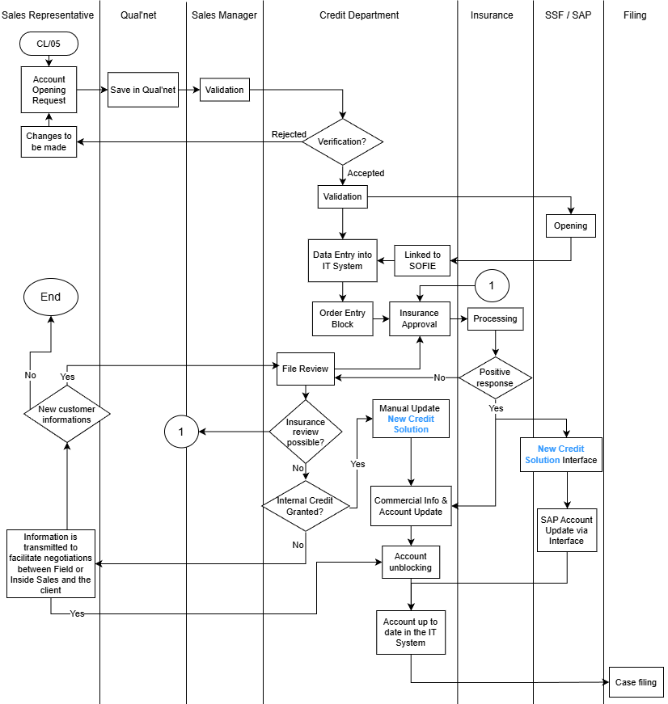

Evaluation of request

Case 1: Administrative address = billing address
In this case, the customer you wish to create is billed to himself (only one address). You need to check whether the SIREN number already exists in Sofie.
To do this, use menu 03 / 01 / 06 then F4 to enter the SIREN in the Sofie search:

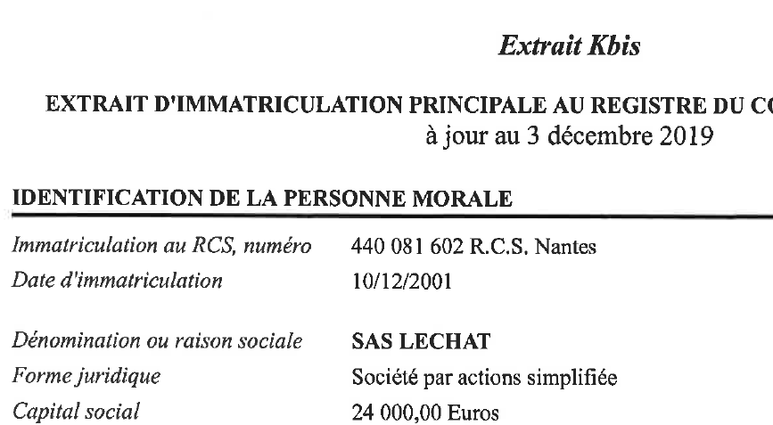
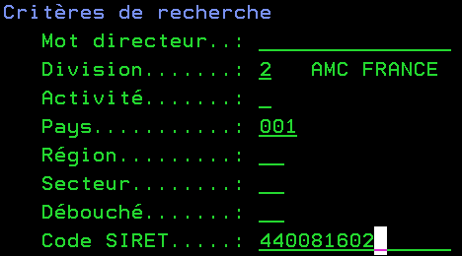

In this example, the SIREN of customer LECHAT is 440 081 602

If you search by name in Sofie and find a LECHAT account with a different SIREN, you won't be able to use it (different identity).

In fact, this means that the company has probably changed its SIREN following a takeover, liquidation, cessation of activity, or that is another company with the same name.
→ Therefore, you'll need to open a new account

If you find the LECHAT customer with the same SIREN but a different address, you will need to ask the customer for confirmation that this is indeed a change of address
→ You will then need to modify the customer file

RECAP DIAGRAM - CASE 1
(Administrative address = billing address)

Same SIREN, different address
No existing account
The sales rep can use this account
Same SIREN & same address

YES
NO
Other existing company at this address
Customer's previous address?
Order received at sales office
Search for SIREN in SOFIE

Account opening by sales representative
Modification of customer account by sales representative

Case 2: Administrative address ≠ billing address
In this second case, a distinction is made between the concepts of agency and invoiced account.
Several agencies can be billed to a single account (often the head office, which makes the payments).
As in the first case, the first step is to systematically check whether the invoiced account exists in Sofie. If it doesn't, you'll need to open an account.
Once you've checked that the billed account exists and that the address matches, you'll need to check that the agency hasn't already been opened in the system.
To create an agency, you need to send an order form to the customer credit department, sp ecifying the following information:
- Itinerant, sedentary, managerial code
- Group attachment code (900xxx)
- EDI number, if the customer uses this system to send invoices

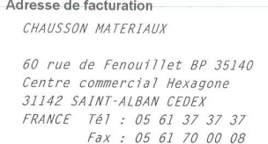
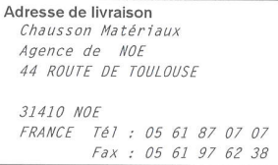

Search for SIREN in SOFIE using F4, then ENTER

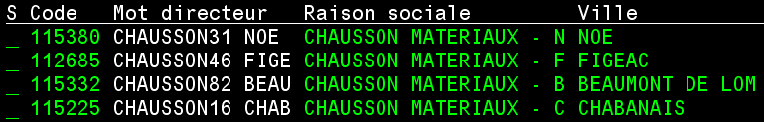


If the address of the account invoiced is not up to date, you will need to make a customer modification under QN
If the agency does not exist in Sofie, the sales assistant will transmit the information to the customer credit department for its creation

RECAP DIAGRAM - CASE 2
(Administrative address ≠ billing address)

Order received by sales rep

Check that billing account exists in SOFIE

The billed account exists at the right address
Billed account does not exist
Account exists but wrong address

Modification of billed account to be made by sales representative

Does the agency exist?

YES
NO

The sales rep can use this account to enter his order
The sales rep must open the account by filling in the agency in the general data and the billing address in the invoicing section.
Send a purchase order to the customer credit department + the necessary information by e-mail (sales codes and group).

Checking the QN file

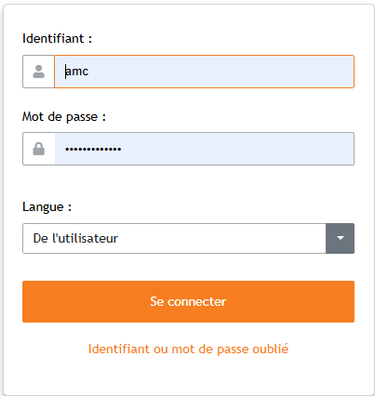
To access the QN file, open the link received in the customer credit mailbox and log in with the AMC session
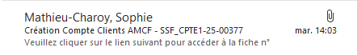

Mandatory fields
Some fields cannot be filled in directly, so use the magnifying glass to select the required data

- Sales data
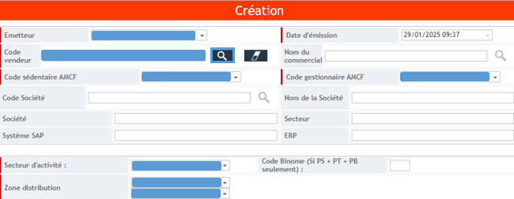

- Customer data
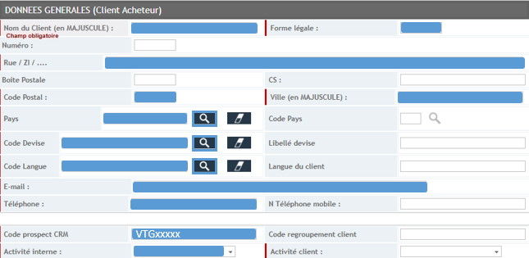

The "CRM prospect code" box must be filled in. However, the sales rep won't necessarily have a VTG code, so he'll still have to fill in the box, either with an "X", a ". " or whatever to indicate that there is none. Otherwise, the format of a CRM prospect code is VTGxxxxx.
- Accounting information
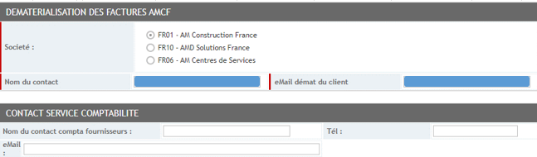

- Customer identification

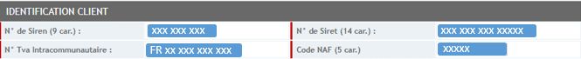

As a reminder:
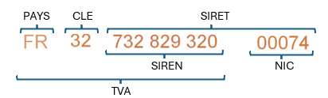

NAF (or APE) code = main activity carried out

- Credit cover
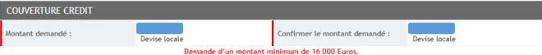

The minimum amount is €16,000 for all activities.

For credits, the amount is always expressed exclusive of VAT
- Invoicing
If the administrative address is the same as the billing address, we are in case 1:
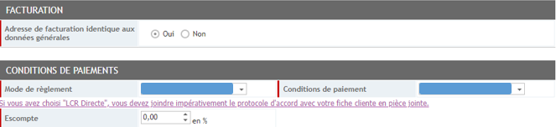

If the administrative address is different from the billing address, we are in case 2:
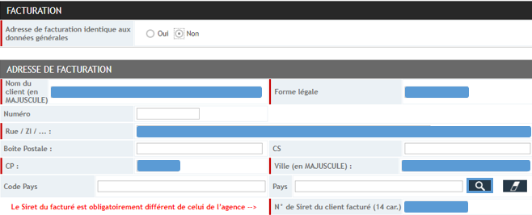

As a reminder, an agency's SIRET will always be different from that of an invoiced party.
Even though we're talking about the same SIREN, each establishment has a unique SIRET that enables it to be identified by official sources.
In exceptional cases, such as for BOUYGUES or EIFFAGE, the billing address is not an establishment, but an address with a TSA (Special Sorting upon Arrival). There is therefore no different SIRET to fill in, as the sales representative will enter the agency's SIRET.

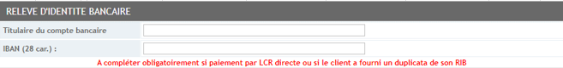

Mandatory for direct LCR payments, as indicated below in the box.

- Shipping & trade information
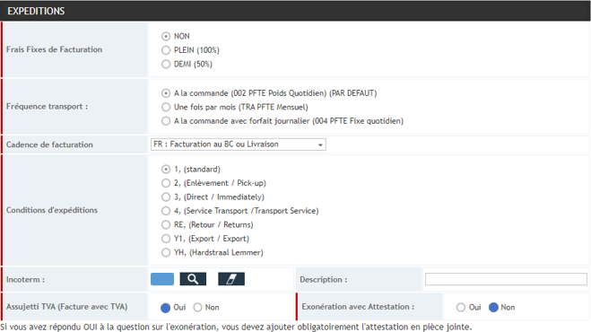

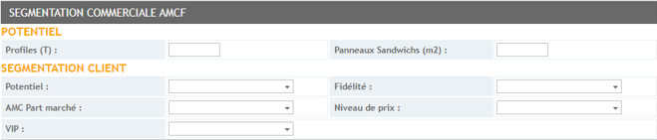

- Mandatory attachments

- KBIS certificate issued within the last 6 months
- Account opening form completed, stamped and signed by customer
- Credit insurance section to be completed and signed by sales representative

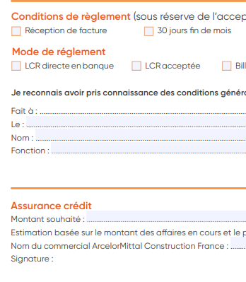

Location:

- If the address you wish to create does not appear on the KBIS, attach a purchase order or letterhead showing the address

- If the customer pays by direct LCR, attach the completed protocol, stamped and signed by the customer + a copy of his RIB (official bank document).

- For sole traders, craftsmen, etc., the KBIS certificate or trade register remains mandatory

- For foreign companies, please enclose a trade register or equivalent official document from the country of origin.

- Validation / refusal
→ If any of the data is incorrect or a document is missing, click on the "Refusal" box on the left to refuse the form to the sales representative (the other box is for the branch manager).
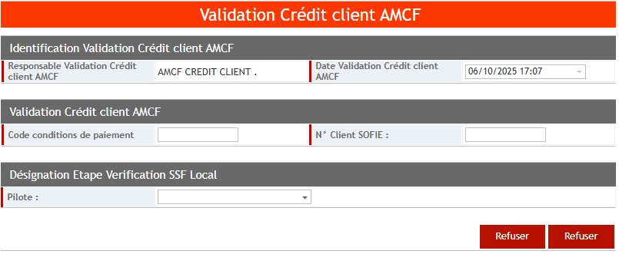

Indicate the reason(s) for refusal, then validate:
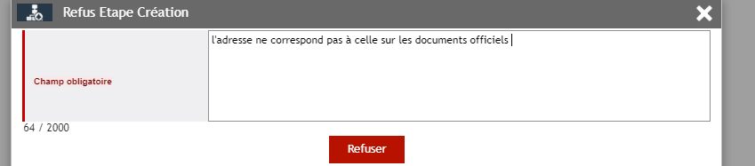

→ If the file is OK, you can go on to create the account in SOFIE (Point 3.)

Remarks:
- When a form has been refused, the reason can be viewed in the form, "History" tab, check "Step history".
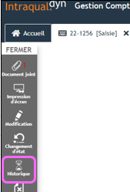

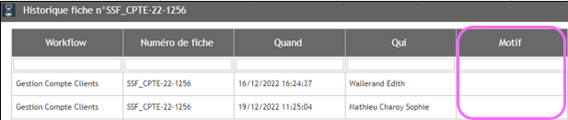

- All blank documents can be found in:
COMMUN_GROUPE / Commercial AMCF / DOSSIER PROCEDURES COMMERCIALES / ANNEXES / FINANCIER

- If a salesperson is not included in the QN lists, please contact Vincent Iozzo by e-mail, indicating:

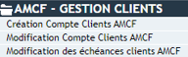
- The workflow concerned:

- Salesperson's first and last name
- The sales code (if you don't have it, ask Sophie Matthieu Charoy).

Once Vincent has confirmed, you can go and check a new file (you'll need to log in with your personal account, not the AMC account).

Creating a billed customer account in SOFIE

Before starting the creation of a customer account, it is essential to send an email to christophe.cheval@arcelormittal.com to check the customer’s risk index (Dow Jones). This verification ensures that the client does not do business with high-risk countries or sectors (for example, Russia, Iran, or other sanctioned countries) and thus protects the company from legal, financial, and reputational risks.
Please note: When creating your account, make sure to systematically log out of your session. Automatic processing jobs are launched from 12:00 PM onwards, and any session left open may block the process.
To create an account in Sofie, access the "customer update" menu: 03 - 01 - 05 - 01 and enter the new customer code according to the internal activity entered in the QN file:
- Folding: 111xxx
- Envelope: 116xxx
- Galva: 600xxx
(NB: All activities other than folding and Galva are Envelope)
(To define the number to be used, go to K / Customer credit / Batch QN, open the Batch QN file and see the last number used, in order to use the next one).
Then press ENTER
Complete the information using the data in the QN file and in the attached documents
(When opening a branch and a billed account, always starting with the billed account. In this way, when the agency is created, the invoiced account information can be entered directly.)
Please check the VAT number on Creditsafe. If the N° is not identical with the Qual'net file, please refuse the account creation request.

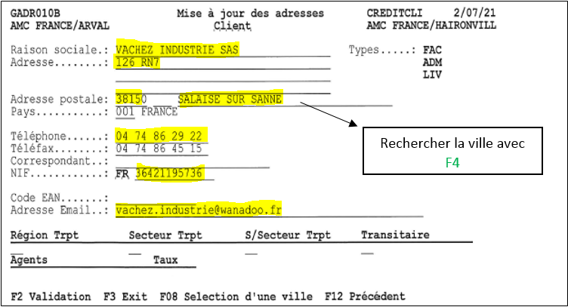

Search for city using F4

VAT N°, the country identifier is automatically completed according to the country entered above

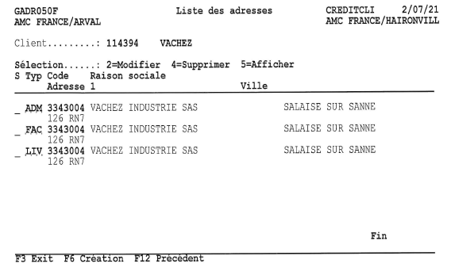

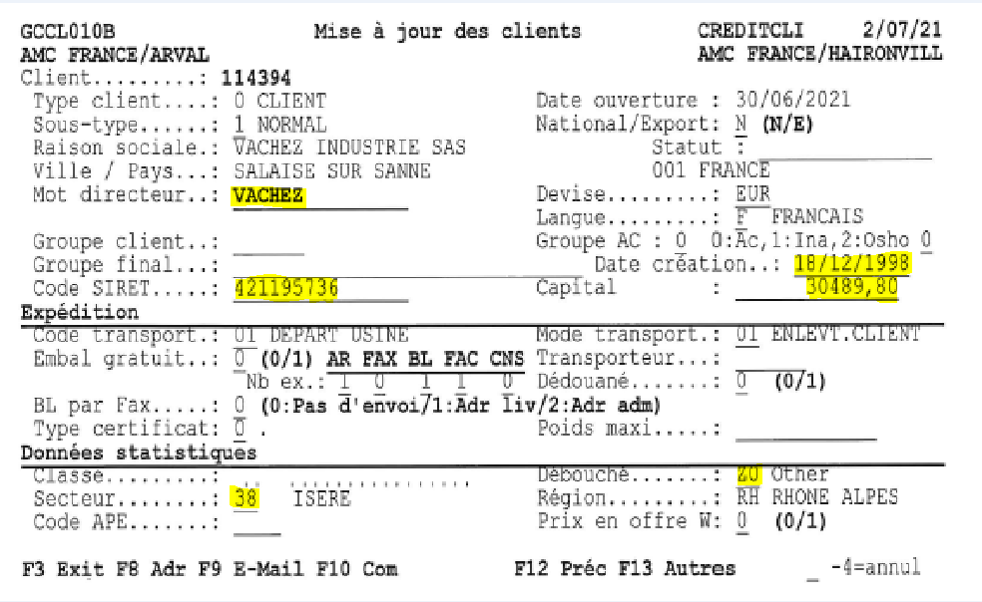
Department
For foreign countries, search for the country with F4
SIREN (KBIS)
Customer activity (QN form)
Registration date: (format DDMMYYYY) Capital: check KBIS

To be entered if customer belongs to a customer group (must be entered in QN file)

Enter name in F4 menu, search by name

Once everything is completed, press F13 (Shift key + F1) to access the next screen:
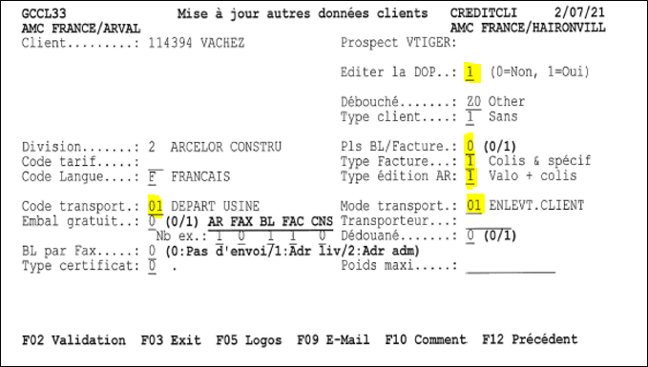

Fill in 03 for "Code + Transport mode".

Press ENTER
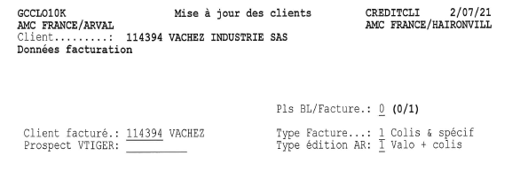
IF entered in the ODC by sales rep (CRM prospect code)
If the billing address is different, you must create the billed account and enter its code on this line, otherwise do not change it.

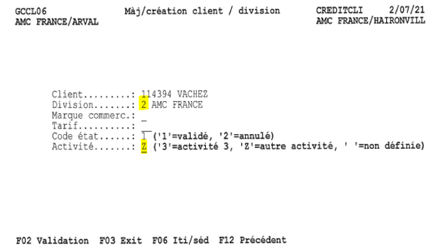
To continue, press ENTER 2 times to reach the next screen, complete as follows:

2

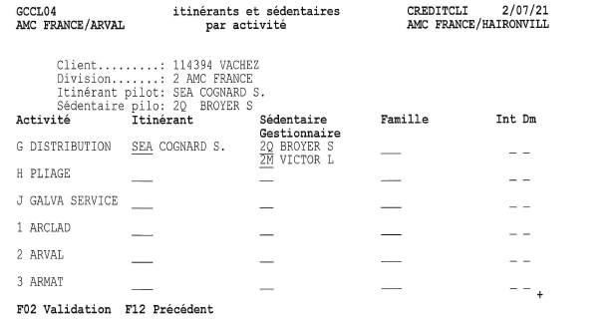

*
*
*

- Fill in the relevant activity line.
- Look up the activity entered in the QN sheet and position yourself on the corresponding line in Sofie.
- Then enter the itinerant code (sales code under QN) and the sedentary code.
- Press ENTER then fill in the manager code
CAUTION: NEVER DELETE A CUSTOMER ACCOUNT IN THE EVENT OF INCORRECT CUSTOMER INFORMATION OR DUPLICATE ENTRIES. INFORM YOUR MANAGER IMMEDIATELY. (It is strictly forbidden to delete anything in the menu (03 / 01 / 05 / 07))

Example under QN:
*
*
*

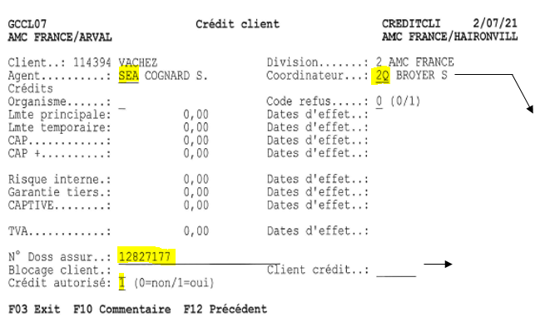
Then press F2
To complete insurance fields, complete insurance application procedures 1.1.1.8
*
*

Atradius no.:
To be completed systematically (see procedure 1.1.1.8)

To be filled in if the master customer is different from the account being created.

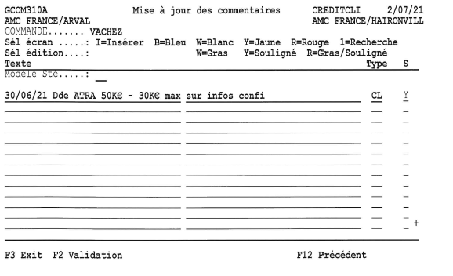

Always CL
1

Comment color:
Choose color then click on ENTER Blue = request in progress
Yellow = decision received
Red = credit modification / cancellation
- Date of comment
- Application to X insurance company with amount
- Accepted / refused
- Reason

Payment codes:
0 - Normal Unlocked
1 - Before Manufacturing
2 - Before shipment

Press F2 to validate order, then ENTER

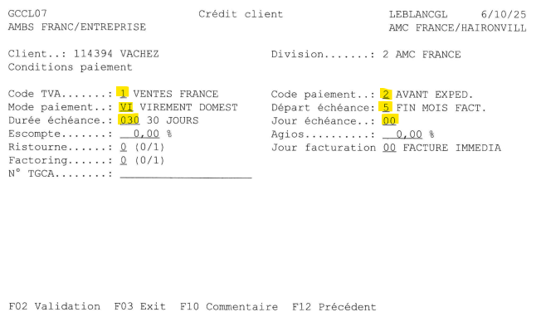

Start date / Due date / Term
30D End of month - 5/030/00 45D End of month - 4/045/99 30D End of month on 15th - 5/030/15 On receipt of invoice - 3/000/00 Before production - 0/000/00
Payment method: Draft TR Bank transfer VI Foreign transfer VJ Group transfer VG Promissory note BO Direct bank LCR TN

(NB: ENTER to check codes.) Then F2 to validate.
→ The account is now created in SOFIE
Warning: for all new customers whose credit has been validated, set the "payment codes" conditions to 0.

Creating a folding account

To create a folding account, first create the account in Sofie, just like a normal account except that you'll need to use an account starting with 111xxx.
Once the account has been opened, go to AX and click on "CRM":
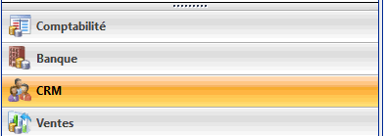

Then select Customers
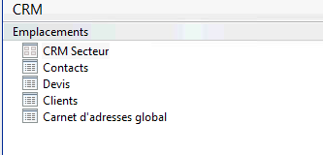

Then click on the customer icon
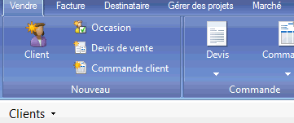

Alternatively, set the folder directly to Favorites as shown below for easy access:
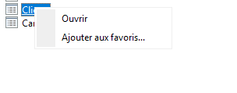

Right-click on Customers, then Add to Favorites...
If the order is already in Favorites:

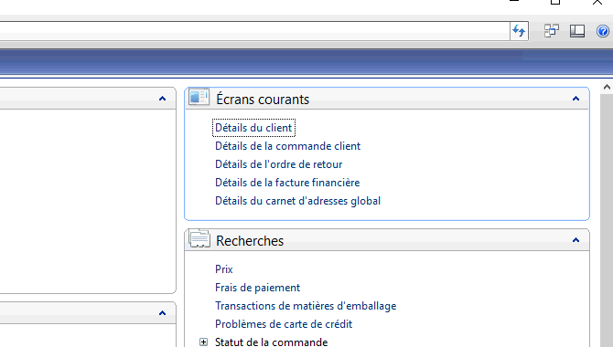

Click on new:
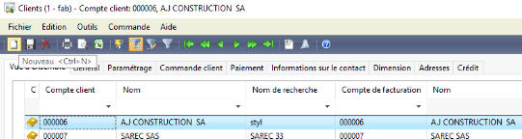

- Overview:

Copy/Paste customer name in "Name", tab to search name. Go to "Customer group" and select "OFF_GPE".
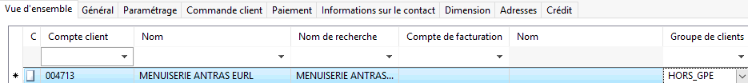

- General

Complete the customer activity using either the QN or SOFIE account and select "9 Hors Grp" in the ArcelorMittal Group box:
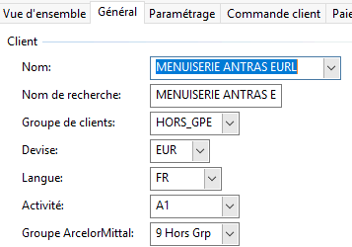

- Settings

Enter tax group: FR - France / Domestic operations
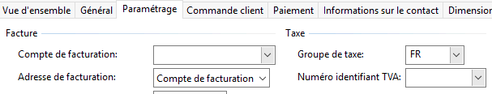

Click on the "Sales order" tab, but change nothing, then click on payment. Also, change nothing and go to the next tab, "Contact information", then:

- Dimension

Fill in the department of the sales rep requesting the account opening (see sales organization sent by Valérie Varin on a regular basis) and select "SEL - SELLING" in "Cost center":
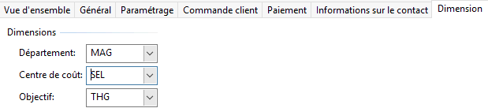

Always in SEL
- Addresses
When you click on the "Addresses" tab, a window opens, click on OK :
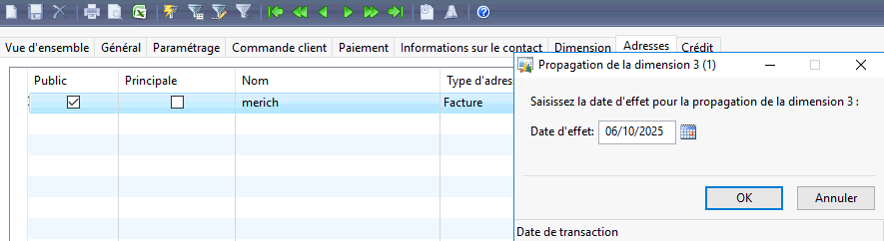

Another window opens:
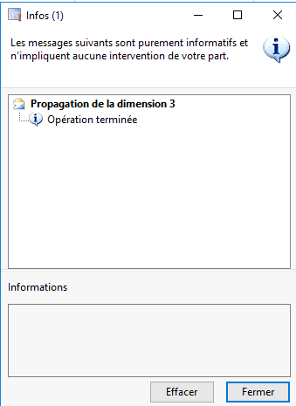

This indicates whether AX has encountered an anomaly.
If so, don't worry, you can close the window

The AX code is displayed on the Customers page:
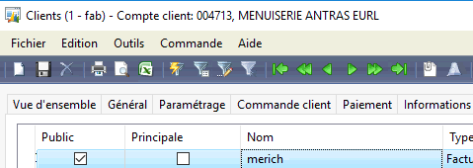

You now need to go to SOFIE in 03/01/05/07, find the customer code and, once on the line, put "7" in front of it:
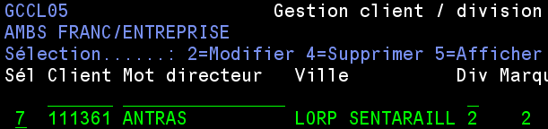

1

The next page will open, and you'll need to enter the AX code on the line below "Folding":
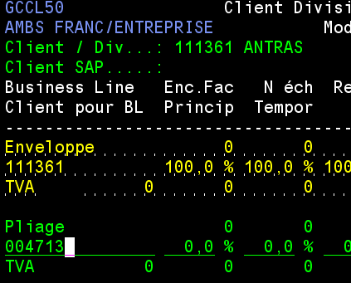

You need to add a % credit for the FOLDING part and then validate by pressing F2
The % of credit is 100% if there is only PLIAGE activity, otherwise check according to orders in backlog and adjust so as not to automatically block the account.

To synchronize AX now, go back to the AX home screen and click on Sales, then in Searches click on "Import customers XML from Sofie".
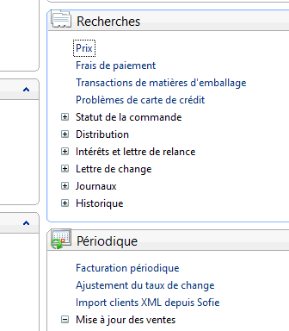
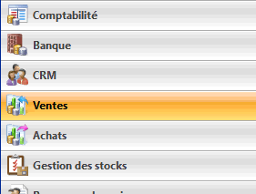

The following window opens, click OK:
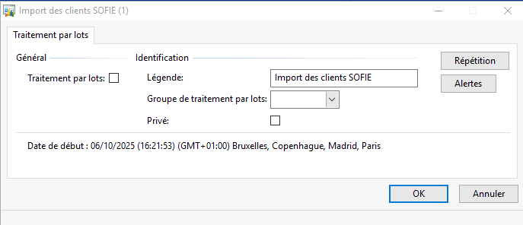

A report opens again, if no error is found, just close the window:
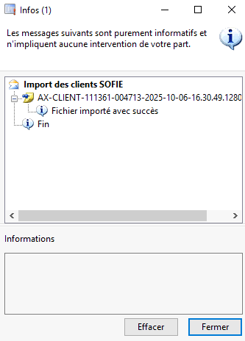

The folding account has been created and attached to the corresponding Sofie code.

Remarks:

- City / zip code anomaly
AX sometimes fails to recognize a town (often due to a hyphen that appears in SOFIE and not in AX). In this case, an error will appear in the previous report, and you'll need to create the town, as noted in SOFIE.

To do this, go to "Postal codes" and click on "New".
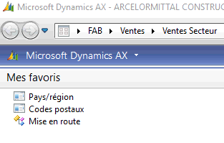

In the "Overview" tab, enter the zip code, city and then tab to "Search name":

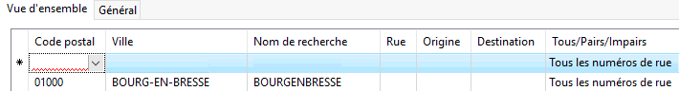

Then go to the "General" tab and complete the "Geography" section:
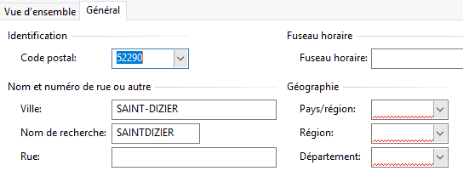

Please note that for regions, the system still works with the old regions
Once you've completed everything, save using the floppy disk:
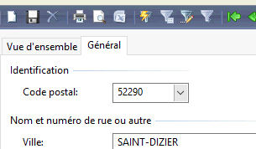

You can close this module, and generate an XML import again
The error should disappear, and the account should be validated in the system

Enter dematerialization

If the customer has requested dematerialization of invoices (invoices sent directly to their e-mailbox, no more mail), it is essential to set up the account accordingly.
To access it from the start menu: 03/01/05/01 enter the Sofie code, ENTER then F9
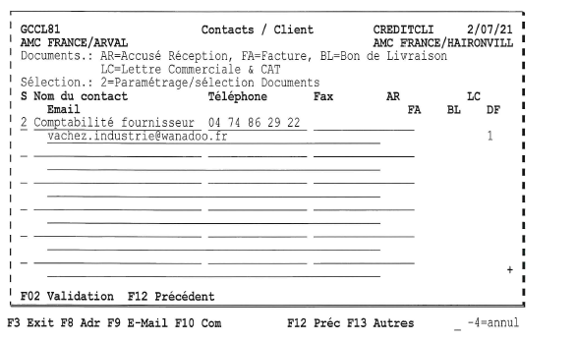

Put 2 on the line, fill in the contact's name (or by default Démat factures), telephone number (use the customer's e-mail number or one already in the contact list) and e-mail address, then press F2:

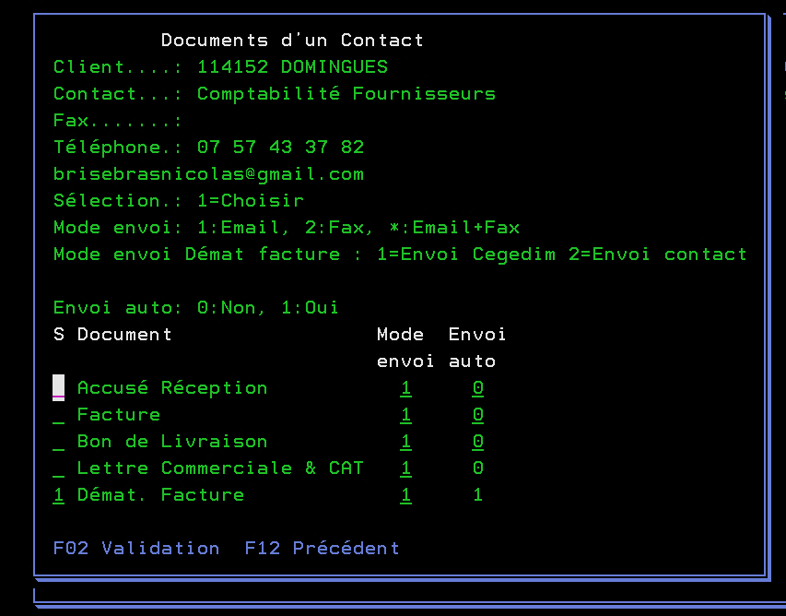

1

Put "1" in front of "Invoice Demat". Invoice", then press F2 to confirm
Folding dematerialization
To dematerialize invoices, it's not enough to enter the address in SOFIE.
You'll need to send an e-mail to Guillaume Bestel, copying the AMBS hotline to request the addition:
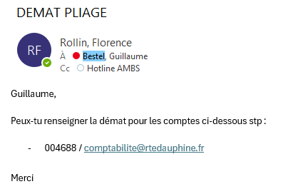

Enter EDI

Some customers use EDI (Electronic Data Interchange) as an alternative means of sending invoices.
To set this up, go to "Customer management" (03 - 01 - 05 - 01).
Once on the customer account, go to addresses (F8), type 2 in front of the ADM address, then ENTER
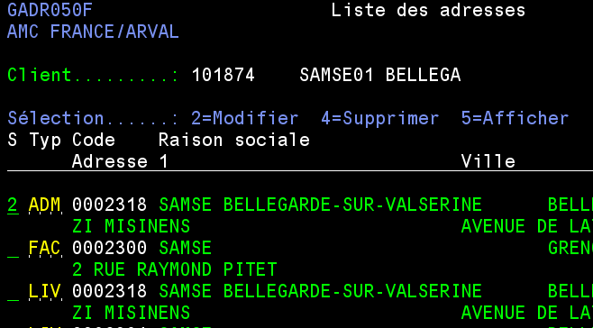

1

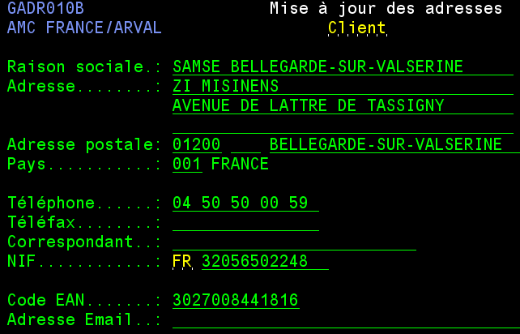

- Enter the EDI code (EAN or GLN), which must be 13 digits long, on the "EAN Code" line.

Then go to the "Update customer/division" menu (03 - 01 - 05 - 07), type in the customer code and ENTER
Put a 2 in front of the customer's line, then F2
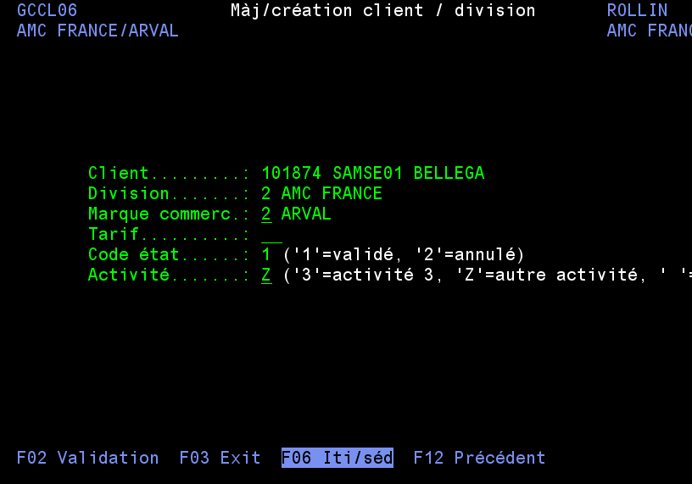

Press F6 and then complete the "Int" and "Dm" columns in the same way as below
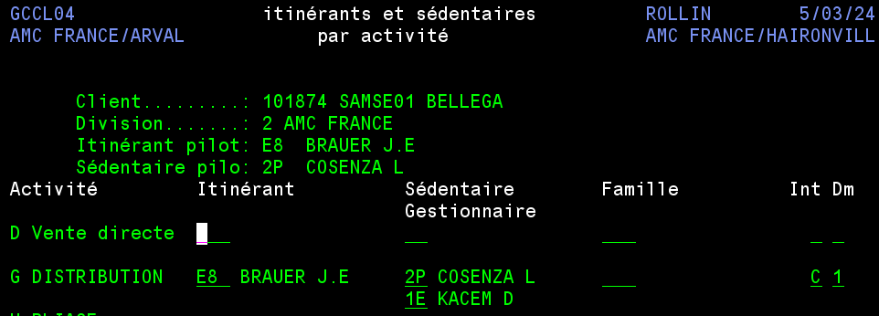

Validate by pressing F2, then exit this menu, the EDI is completed.
Please note that if several activities are entered into the customer account, the "C" in the "Int" column and the "1" in the "Dm" column must be completed for each line.

Enter code SL Partner (ArcelorMittal group)

Each company in the ArcelorMittal group (including France and other countries) has an identification code within the ArcelorMittal structure, known as the SL Partner or BPM code.
It is mandatory when opening an account and must be completed as follows:

In the QN file:
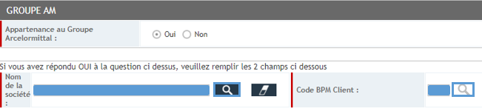

In SOFIE :
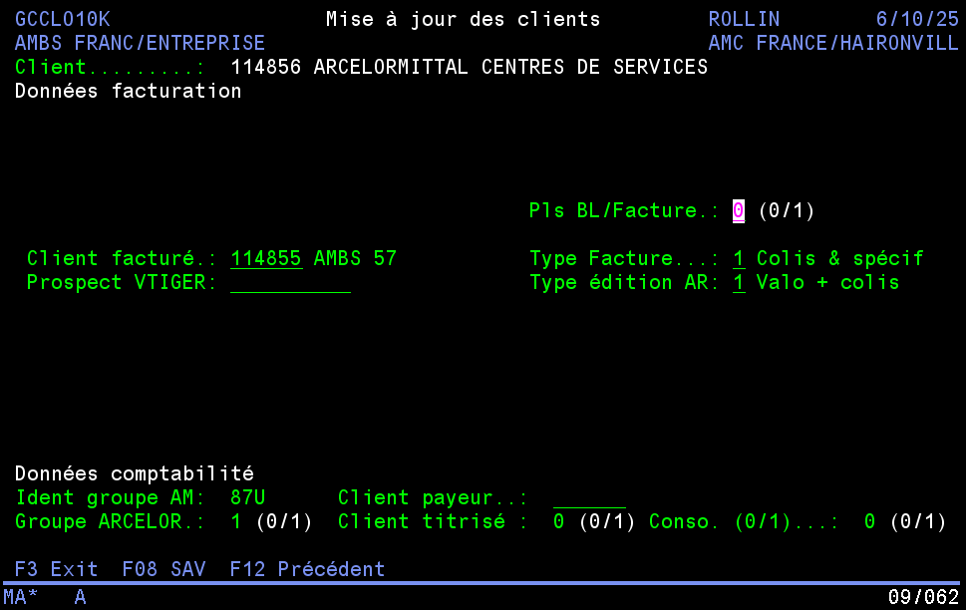

If there is no BPM code, account opening will be refused, and the account cannot be opened in SOFIE.

In menu 03/01/05/01, fill in the line "Groupe AC" with a "1" to indicate that you belong to the Arcelor group:
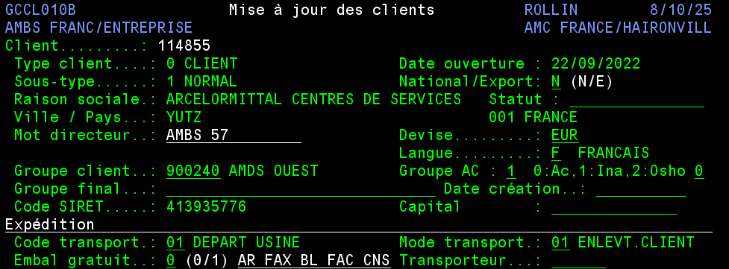

Press ENTER twice to save your entry, then exit this screen.

In menu 03/01/05/07, enter code 9 "Zero risk" in "Organization":
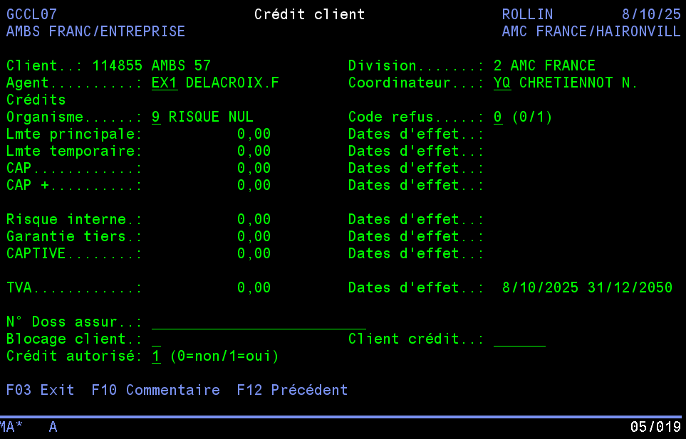

Then, on the next screen, enter the payment method "VG" for group transfer:
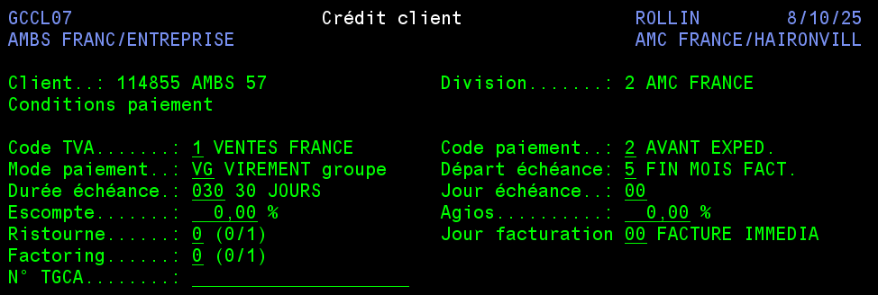

Enter "Customer group" code

The customer group code is a purely commercial statistics account and will not be invoiced.
It can be used to group together a set of customers, with or without the same SIREN number.
For example:
GEDEX - 900092
BLEGER - 900499
DERREY - 900231
LESIMPLE - 900543
BOUILLIER - 900095
107039
115053
115416
001395
…
115178
112427
115179
104603
115863
114833
114918
113509
113082
107383
…

In addition, group accounts are essential for sales management in order to produce statistics according to the desired groups/subgroups and to manage PFA contracts.

It must be filled in when opening an account or specified in the branch creation e-mail.

In SOFIE, go to 03/01/05/01, fill in this line, then press ENTER 2 times before exiting the menu:
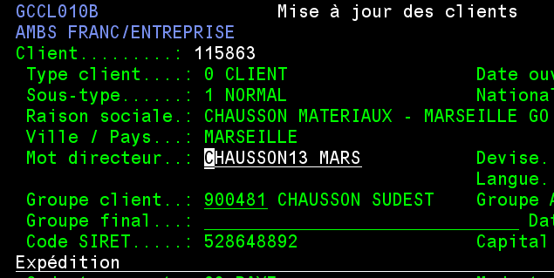

Save documents

- Create customer file under N
- Copy/paste the "...Example folder" from the N server
- Rename to: CUSTOMER NAME - SOFIE CODE (5S requirement)
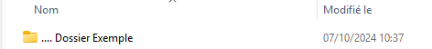

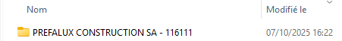

- Save the attachments in this new folder under "Account opening".
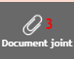
Click on "Attachment
Right-click on each document and select "Save link as".
Select the customer account opening folder

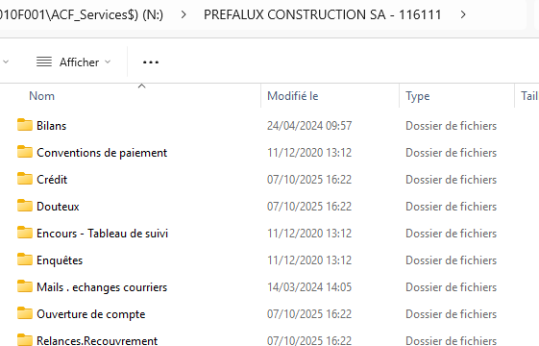

Validate the file
Once all these steps have been completed, the file must be validated so that it can be created by SSF in accounting. To do so, enter the validated payment conditions and the corresponding Sofie code “in pilot”, enter SSFFRANCE CLIENT and then validate the form:
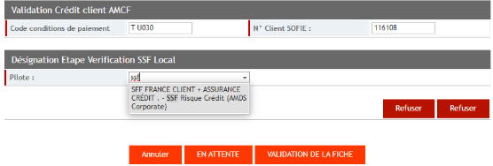

- Save QN file
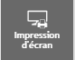
Click on "Print screen", the form will open in a new tab.
Right-click on the file, then print
Select "Save as PDF" from the list of printers
Always save in the account opening folder without changing the name

- Record the credit amendment
Save the amendment (attached document) received in the Accounts Receivable mailbox into the client’s folder, under “Credits”.
Format to be used: Amendment YYYY-MM-DD amount accepted :
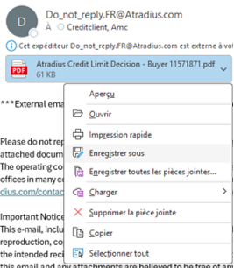

1

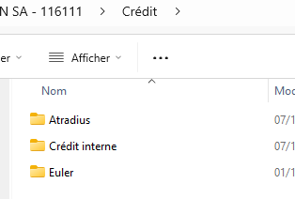

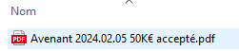

Batch QN

This file lists the various accounts open, with information that can be used for statistical purposes. It can also be used to monitor the status of QN forms received.
- Open the "QN batch tracking" file (here)

- Fill in the required information on a new line:

The Atradius insured number must be filled in, while the EULER number must be filled in only if a request has been made to them.
The AX code is to be entered only if an AX account has been opened.
Internal activity and site are automatically completed according to the sedentary person entered. The same applies to SAP conditions, which are automatically completed using the SOFIE conditions noted.

It is important to update the various lists in the "Tables" tab, especially the list of sales representatives (NAME | ACTIVITY | SITE).

Then save the file before closing it.

Informing sales reps

It is imperative to send an e-mail to the sales staff (field and office-based) to inform them of the creation of the account, whether it is the invoiced account and/or the agency account, and to ensure follow-up. You will need to provide them with the following information:
- Customer name
- Sofie (or AX) code
- Amount of credit granted
- Payment terms validated
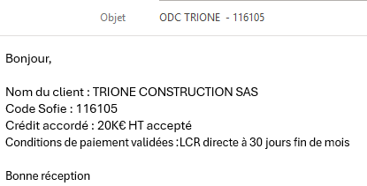

Watch out! For PLIAGE, please enter the AX code by e-mail and send a copy to HENRY Virginie.

Save the mail in the customer folder under N, in the mail folder, by selecting the mail and dropping it into the file, respecting the format "Mail YYYY-MM-DD" in front of the mail subject.
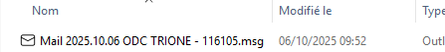

- Ranking of account creation requests:
File account creation request e-mails in the customer credit mailbox
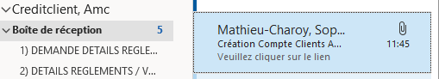

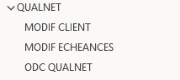

SOFIE - SAP integration (billed account only)

When the account is created in SAP, an integration goes back to AMBSF so that we can make the link between SOFIE and SAP.
Go to the 03/01/05/08 "SAP customers integration" menu:
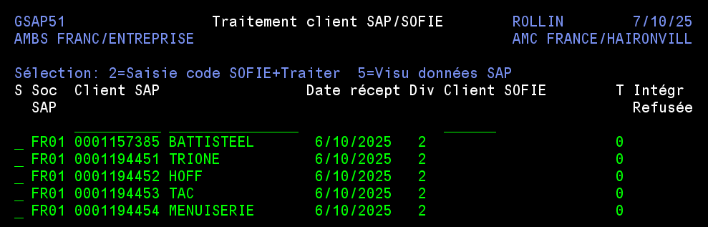

No SOFIE code = no link with SAP

To synchronize, place "2" in front of the desired line and press ENTER:

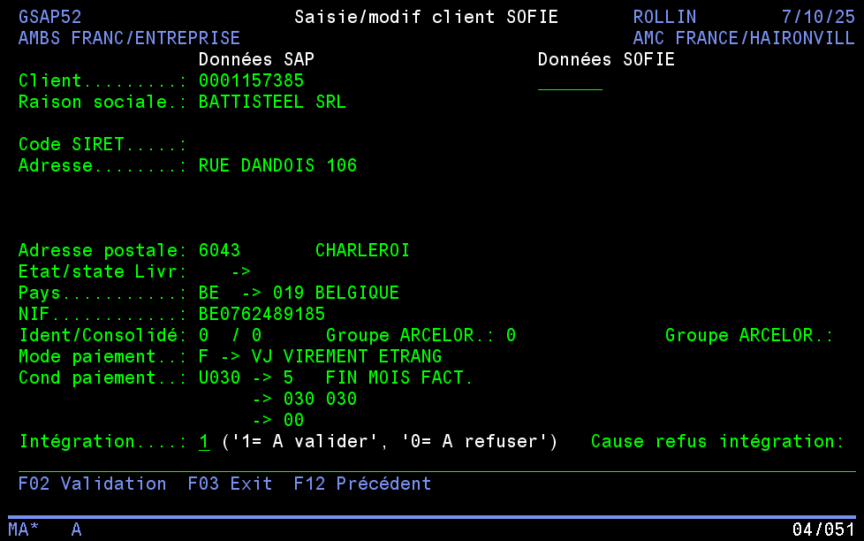

Enter the Sofie code and press ENTER to display the data:
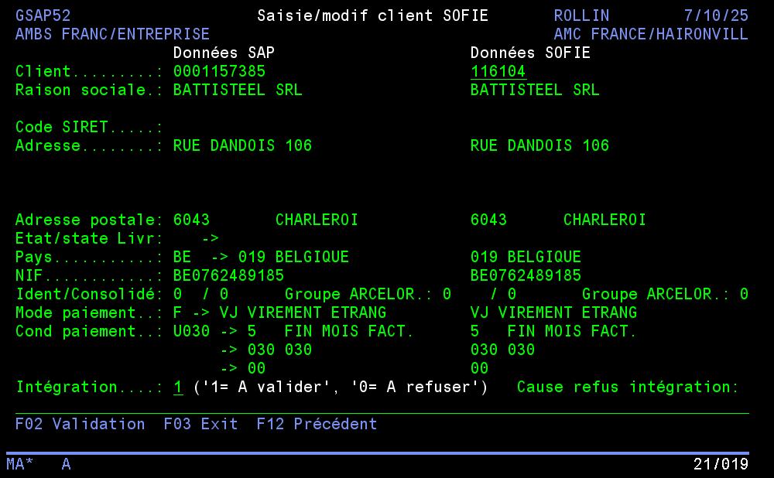

Check that SOFIE data corresponds to data received from SAP

If this is the case, copy/paste the SAP number into the QN Batch file and enter the date on which the integration was carried out:

Then press F2 in SOFIE to validate integration
If you go to credit visualization (03/01/07), you can see that the link has been made:

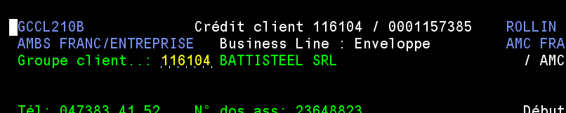

Last step: synchronization in SAP (see procedure 1.1.1.11), which must also be entered in the QN batch files. Finally, the manager will perform the control step, which will also be notified in this file:

If there are any errors in the integration, it must be rejected by filling in "0" in the "Integration" option, indicating the reason on the line below:

Reason to be entered

Then press F2

In parallel, an email must be sent to the client file team in Accounting so that they can apply a correction, ensuring that an updated integration is reflected in the system.

It is important to specify in your e-mail:
- Customer's SAP code
- Customer name
- QN file number concerned
- The corrective action required
- An attachment or capture justifying the request

Once the new integration has arrived in the system, if it is correct, you can validate it (start of M.)

End of account opening

